Create a list of tuples, where the 1st element of the tuple is an int and the second

element is a string.

Example - ((1, ‘alpha’), (2, ‘beta’), (3, ‘gamma’), (4, ‘zeta’), (5, ‘omega’))

-

Var list = List((1, “alpha”), (2, “beta”), (3, “gamma”), (4, “zeta”), (5, “omega”))

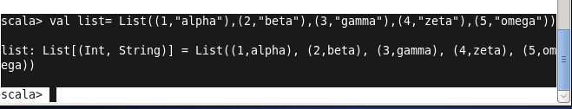

for the above list, print the numbers where the corresponding string length is 4

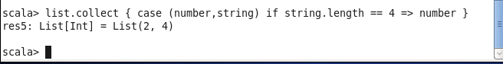

- find the average

